**How to control servo motor Turnigy TGY-S518D (Chinese clone of Robotis Dynamixel MX-28)**

Actually, there aren't any datasheet of this servo motor on Internet. The only info is provided on <https://hobbyking.com/en_us/turnigy-tgy-s518d-300-digital-metal-gear-intelligent-robot-servo-16-5kg-0-19s.html?___store=en_us>

Communication Protocol: RS-485, which make it compatible with Robotis Dynamixel communication protocols, but...

it is impossible to control "Chinamixel" via Dynamixel Wizard through USB2Dynamixel adapter, because the original software checks for originality of a motor. Being more specific, Dynamixel Wizard is able to find it, thereby prompting the baud rate (**500kHz**), but do not allow any further actions with TGY-S518D.

**Using Arduino**

So, here is the method of controlling "Chinamixel" using Arduino Mega 2560 and MAX485 which interfaces Arduino to RS-485 protocol (more info: <http://hobbycomponents.com/wired-wireless/663-max485-rs485-transceiver-module> ).

1. **Connection:**

|  |  |  |
| --- | --- | --- |
| **Arduino** | **MAX485** | **TGY-S518D** |
| Pin 2 (direction pin, this pin controls the MAX485 enable) | DE | - |
| RE | - |
| TX0 | DI | - |
| RX0 | RO | - |
| GND | GND | GND |
| 5V | VCC | - |
| - | A | Data + |
| - | B | Data - |

* Remember: there is a common ground for all connect devices; set current limit t ~ 1A.
* Only TX0 and RX0 can handle 500K bps (with a 16MHz clock the serial port can handle 1Mbps). Other serial ports are limited to 115200 bps, to use them, firstly, change baud rate with “Dynamixel.setBD()” function. (*some TGY-S518D can’t store new baud rate! Every time when power supply turned off, it’s baud rate change to initial 500k bps.)
* RS-485 supports up to 32 independent channels, so you can control many servos with nothing more than an Arduino and one MAX485 module! Just remember to give your servo a unique ID.

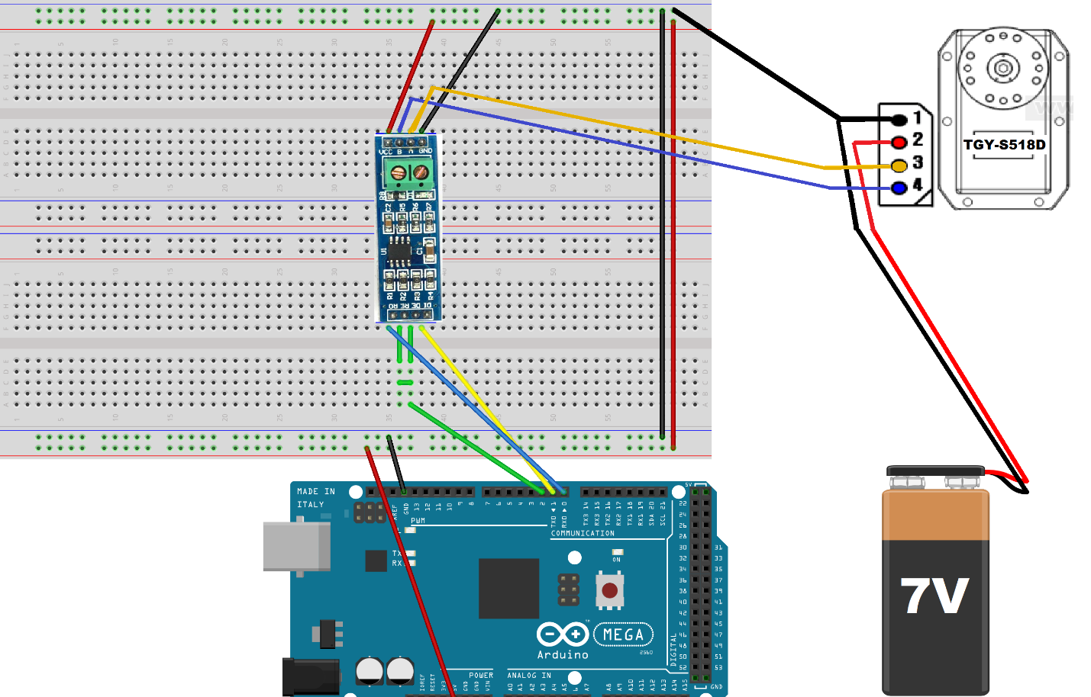

1. **Sofware:**

* Download and install library for Dynamixel from <https://github.com/OpenBionics/Robot-Hands/tree/master/Software/Arduino/Libraries/DynamixelSerial>
* Set the baud rate to 500K
* By default, ID = 1. But you can use “broadcast ID” which is 254.

**Through PC terminal**

Knowing motor’s protocol, it is easy to control chinamixel without any additional devices. Only things that needed are RS485toUSB adapter (like USB2Dynamixel adapter).

**Изображение выглядит как земля, дорога

Описание создано с высокой степенью достоверности**

1. Turnigy TGY – S518D has protocol similar to Dynamixel MX Protocol 1.0 (<http://emanual.robotis.com/docs/en/dxl/protocol1/#communication-overview> )
2. We took a library that we used for Arduino ( <https://github.com/OpenBionics/Robot-Hands/tree/master/Software/Arduino/Libraries/DynamixelSerial> ) and rewrote it in python.
3. To run the file in terminal (Linux Ubuntu) type:

**“***$ python -c “execfile(‘FILE.py’); command (variables)”* **“**